Bear Cubs Newsletter
Wk. beg: 25th April 22’
Dear Parents/Carers
I hope you all had an extremely relaxing Easter – at least the weather was kind to us!
This week we are reading a story called ‘The tiger who came to tea.’ It’s about a tiger who knocks on the door of a little girl’s house and goes in for tea but he eats and drinks everything! Thinking about the story in the next couple of weeks we will be learning about good manners, visiting cafes and painting tigers.
Vocabulary: Polite, rude, considerate, greedy
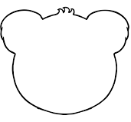
In Maths we are learning number bonds to 5. We need to develop good recall of these facts by June so at home practise splitting 5 objects into two groups to support this understanding.
Remember to ask a member of staff for a bear to fill in to tell us what your child has been doing.
Vocabulary: Add, plus, total, altogether, equals
Comment:

Name:

Our new website is up and running now so remember to check our class blog to see what we’ve been doing!

