|  |
| --- |
| **Kexborough Primary School** |
| school logo12023-2024 : Newsletter #14 |
| Monday 8 January 2024 |

|  |  |  |  |  |  |  |  |
| --- | --- | --- | --- | --- | --- | --- | --- |
| Attendance | | | | Whole School  (Week 15) | | Whole School  (To date) | |
| 93.5% | | 95.2% | |
| FS1 | FS2 | Y1 | Y2 | Y3 | Y4 | Y5 | Y6 |
| 87.7% | 94.4% | 93.7% | 87.4% | 93.5% | 97.9% | 96.3% | 93.8% |

*The requirement is if your child is going to be absent from school that daily phone calls are made to the school office on 01226 382288 providing a reason for their absence before 9am. Failure to make contact with school will result in your child’s absence being unauthorised. Absence can also be reported via email on KPSAttendance@ecmtrust.co.uk*

|  |
| --- |
| Christmas Fair |
| Thank you to everyone who supported our Christmas Fair during the last week of the Autumn term. We raised just over £900. Thank you so much for your generosity. |
| Y6 Enterprise Project |
| Thank you to everyone who bought the gonks that had been made by the Y6 children as part of their enterprise project to self fund their trip to the theatre in March.  The children have currently made over £350 in profit so have been able to pay school back for the ticket costs of £336. They will now be looking at further initiatives to fund the cost of the coach.  Thank you for all of your support for this project. |
| Coffee Morning |
| Miss Warburton will continue to hold her regular coffee mornings throughout the Spring Term. The dates for these are   * Monday 15th January 2024 * Friday 26th January 2024 * Friday 23rd February 2024 * Friday 15th March 2024   The coffee morning on Monday 15th January will have a SEND focus. This coffee morning is for parents / carers who would like more information on what support is available within Barnsley for children who have additional needs. Fran Whayman and Lynn Smith (SEND Improvement Officers) will deliver The Graduated Response PowerPoint and will discuss the EHCP process. Fran and Lynn will be available to answer any of your questions.  If you require any further information please do not hesitate to contact Miss Warburton. |
| Peak Venture – Parent / Carer Meeting |
| The parent/ carer meeting with regards to the Y4/Y5 residential visit will take place at 3:45pm on Monday 22nd January. This meeting will be held in the Y5 classroom. |

****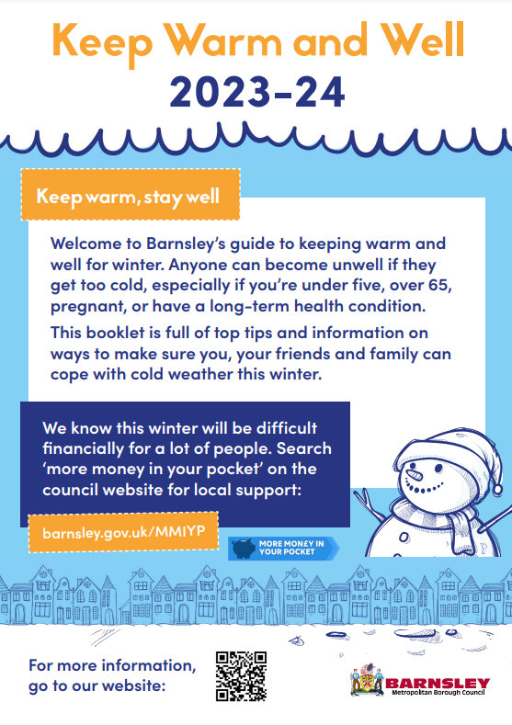**Wider Services and Information**



**School Calendar**

**School calendar**

|  |  |  |
| --- | --- | --- |
| **CHRISTMAS HOLIDAY** | | |
| Monday 8th January 2024  9:00am | All | Return to school after Christmas break |
| Tuesday 30th January 2024  AM | Y4 | Swimming Lessons begin |
| Friday 2nd February  All Day | All | NSPCC Number Day |
| Friday 9th February  3:30 | All | Break for February Half Term |
| **FEBRUARY HALF TERM** | | |
| Monday 19th February  All day | All | INSET DAY |
| Tuesday 20th February  9:00 | All | Return to school after February half term |
| Weds 6th – Fri 8th March  All day | Selected Y4 and Y5 | Y4/5 Residential |
| Tuesday 12th March  After school | All | Parent / Carer Review Meetings |
| Wednesday 13th March  After school | All | Parent / Carer Review Meetings |
| Friday 15th March  All day | All | Comic Relief |
| Friday 22nd March  3:30 | All | Break for Easter holidays |